**ASSIGNMENT(WEEK 1)**

Name: Jeff Easow

Registration Number: 20BCT0028

VIT, Vellore

**TINKERCAD CIRCUITS**

**LED TRAFFIC LIGHT**

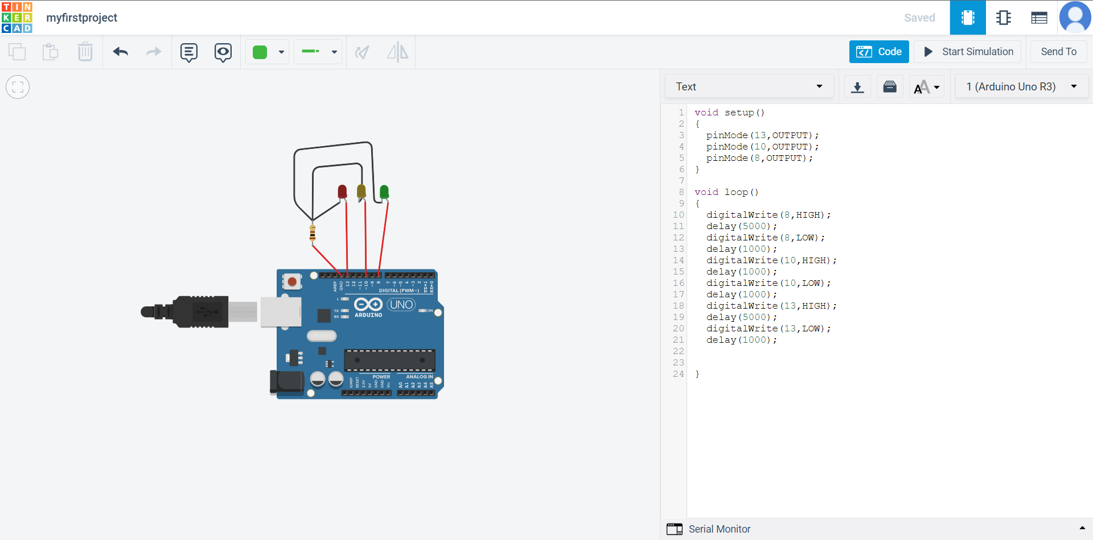

Link: <https://www.tinkercad.com/things/e80CO3WZ4dI?sharecode=8QJ8W_kMRX00mm3z84MpncRpGKmm7GL2CIz-mQX90no>

**DIGITALREAD(BUTTON CONTROLLED LED)**

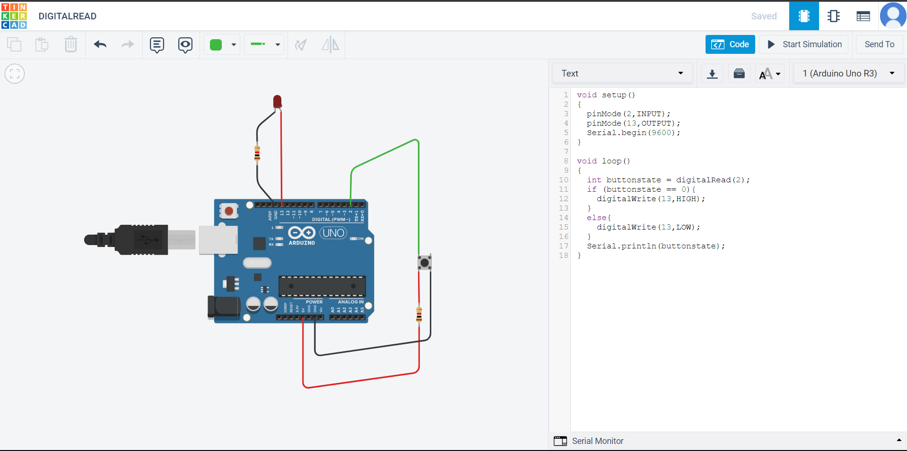

Link: <https://www.tinkercad.com/things/j3tf8uVqQqG>

**ANALOGREAD (POTENTIOMETER CONTROLLING LED INTENSITY)**

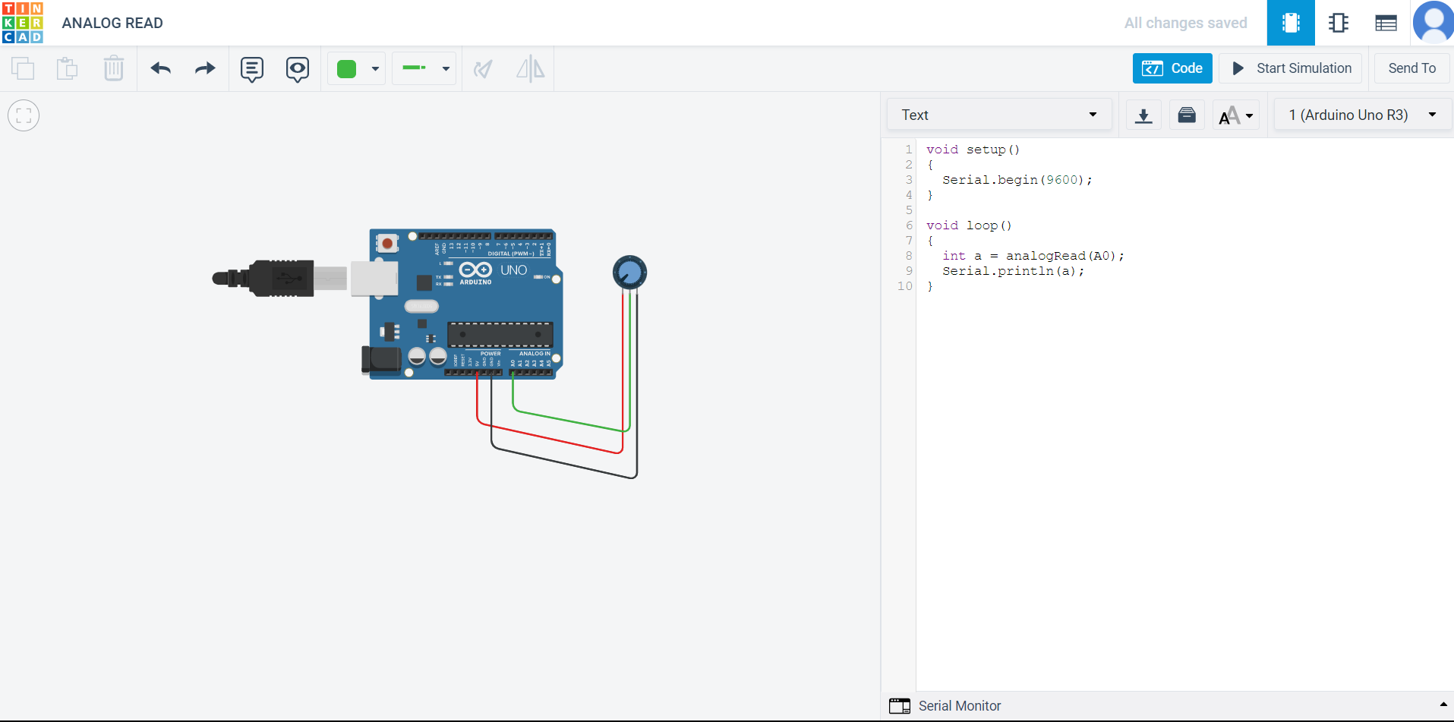

Link: <https://www.tinkercad.com/things/apYvMRmfjhm>

**RGB LED**

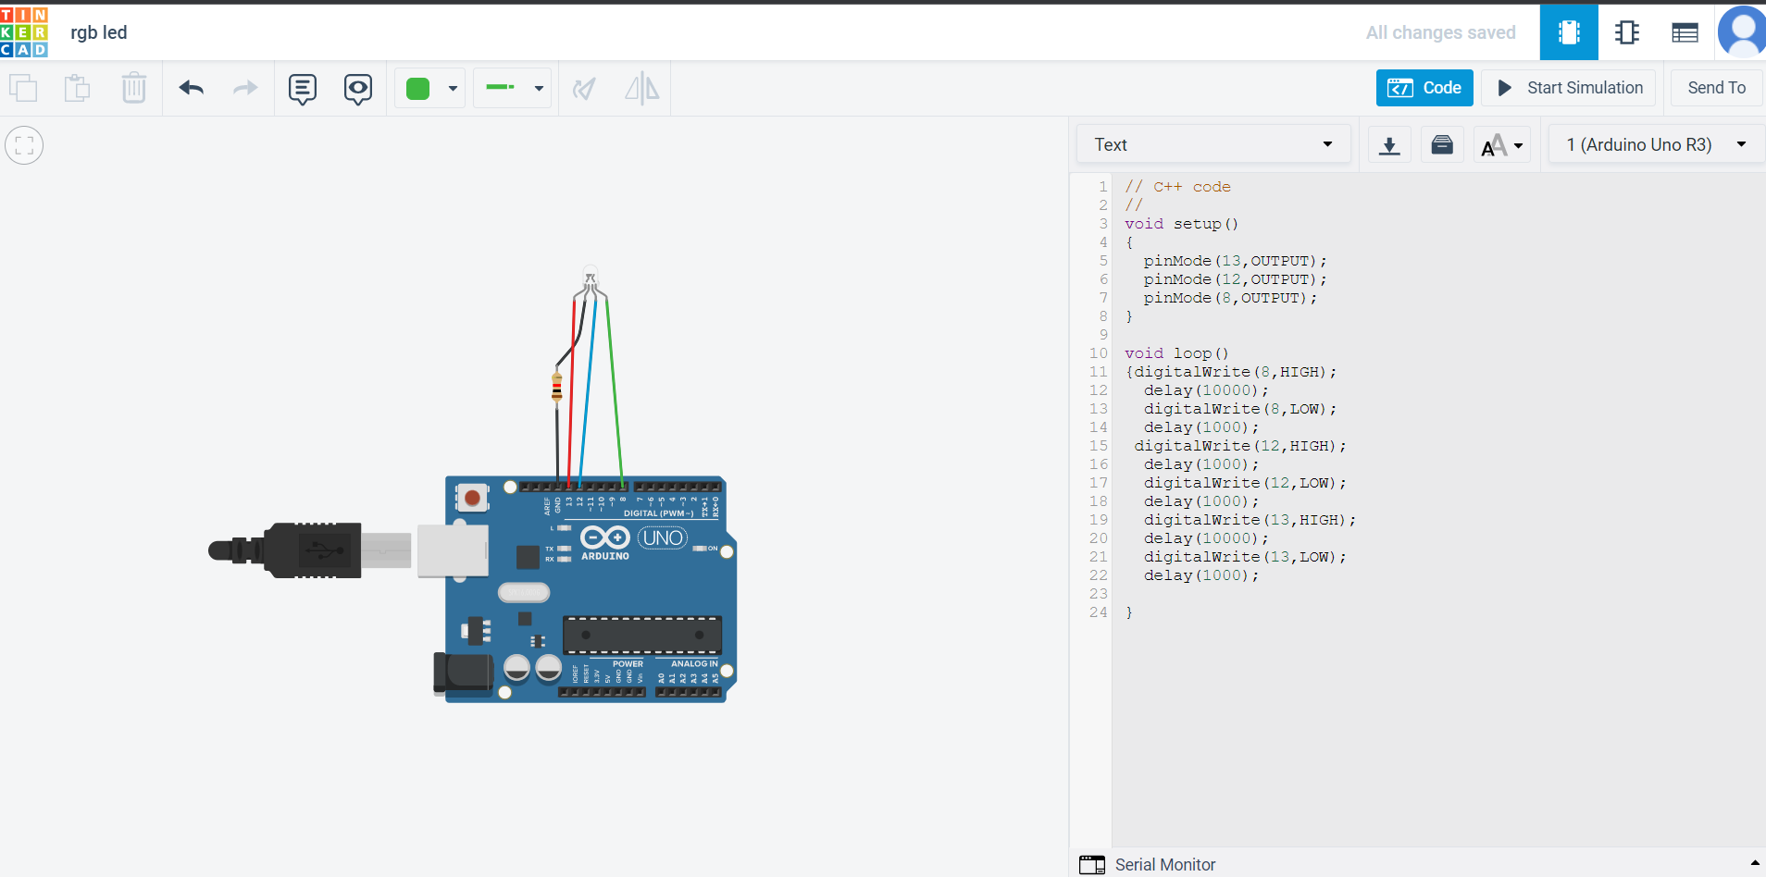

Link: <https://www.tinkercad.com/things/kz8PtDqpTkc>

**BUZZER**

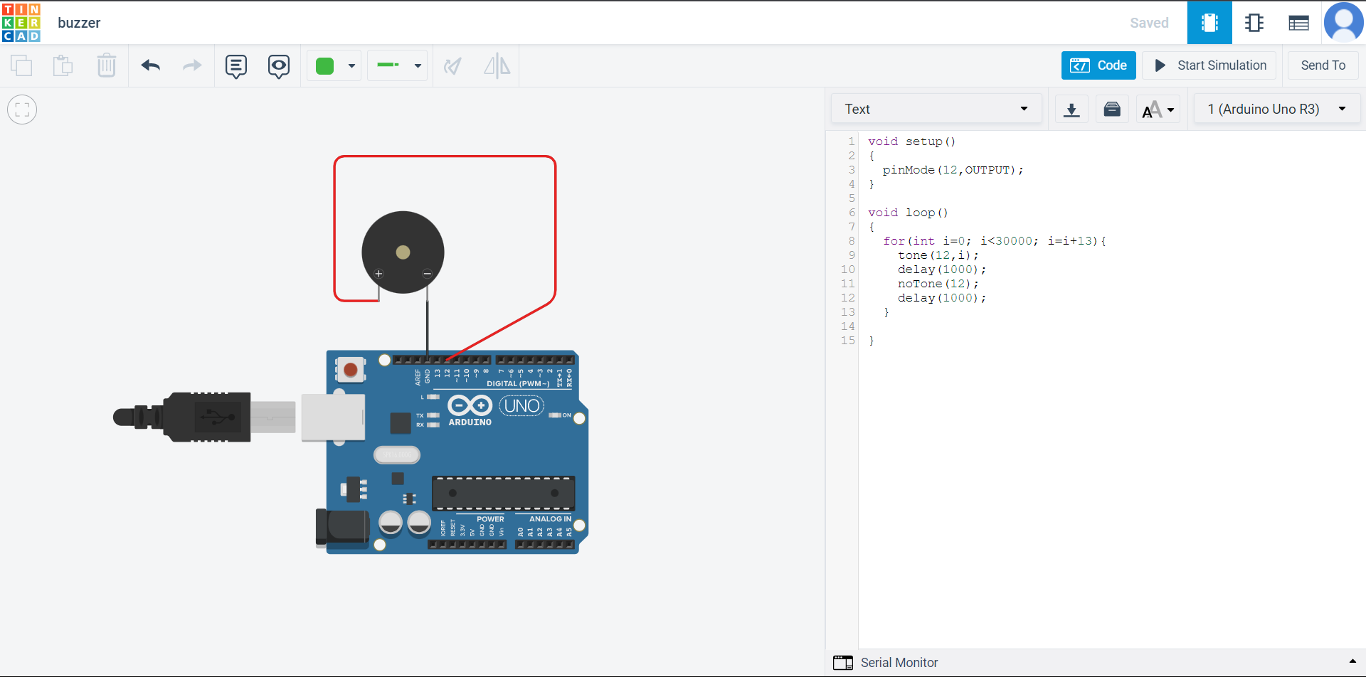

Link: <https://www.tinkercad.com/things/lDxC45itViX?sharecode=7bNji8GOkp1lPKIlA-TuAA7j0lkOwP9tzhDOzd8MeWc>

**ULTRASOUND SENSOR**

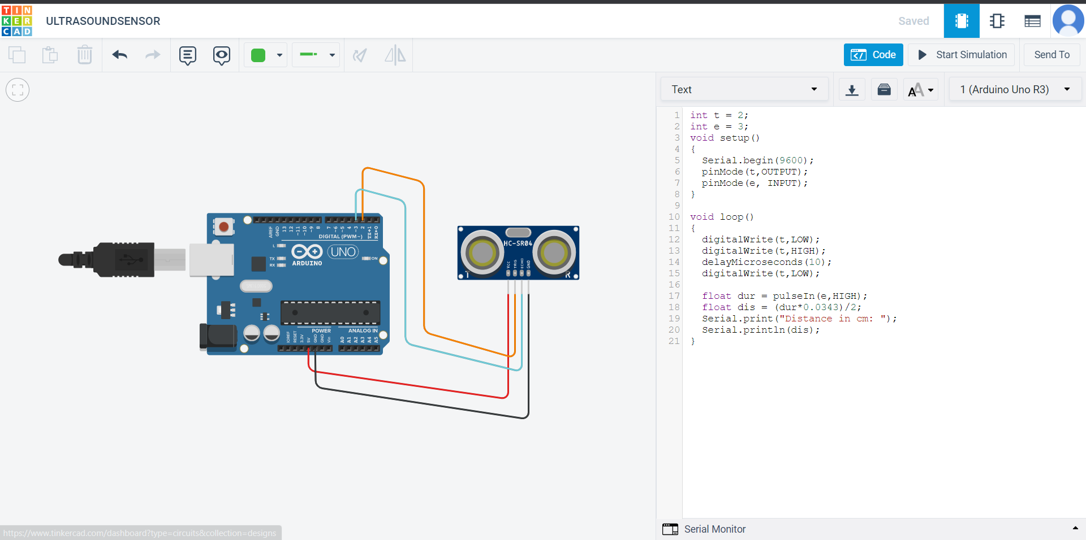

Link: <https://www.tinkercad.com/things/7vhlumbrcTa?sharecode=ft5_CPglPzklVsonlGZBn8K4F8m2b6qYoyOOBHTinZ4>

**TEMPERATURE SENSOR:**

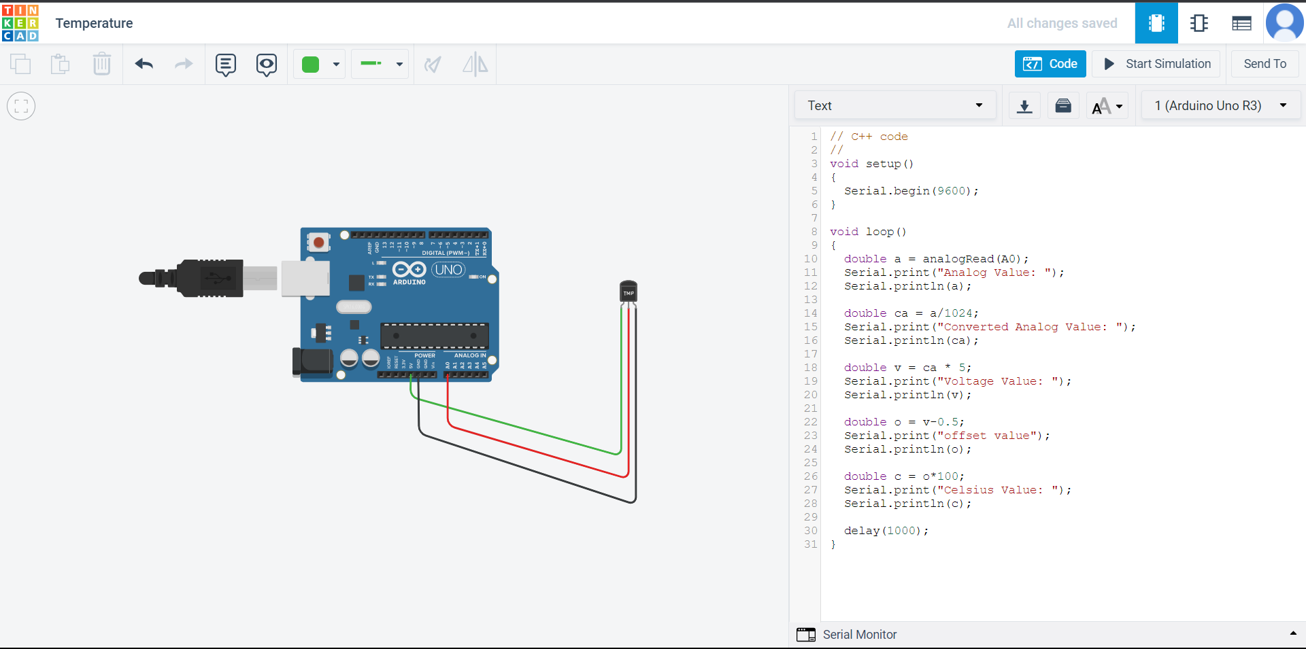

Link: <https://www.tinkercad.com/things/8JRS76nTolq?sharecode=uddrixEsTXeThyqwyRbXpRTSKe4zyfMG8FbntI46HQQ>

**PIR SENSOR**

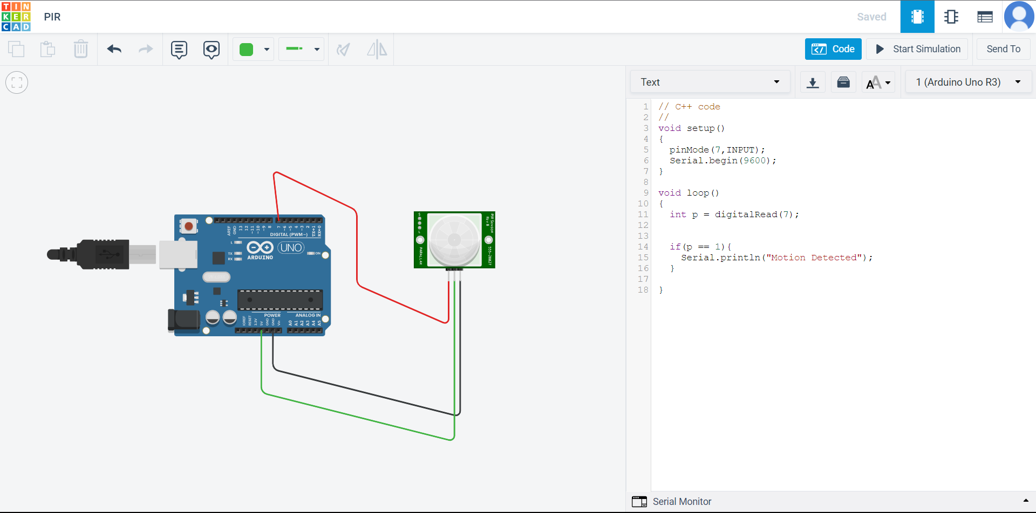

Link: <https://www.tinkercad.com/things/kXuoVREgJQX?sharecode=7_oZDYFspW6UK76yPvcZsAIoEhUAJrmwiDZjry3cYCw>

**SERVO MOTOR**

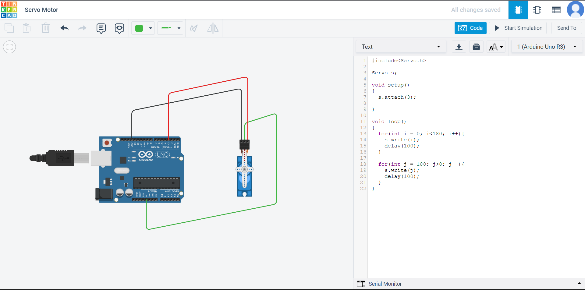

Link: <https://www.tinkercad.com/things/7r1YdtSAQmV?sharecode=Bsq1HPFReYJI_KRvQW2iNDTXhYEda5_XG3lrEPliGZw>